CLiPPA Winners
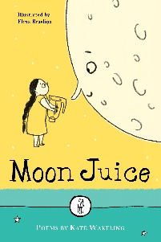
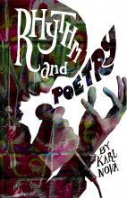
2018 CLIPPA
Karl Nova for Rhythm and Poetry (Caboodle Books)
2017 CLiPPA
Kate Wakeling for Moon Juice (The Emma Press)

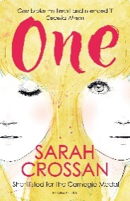  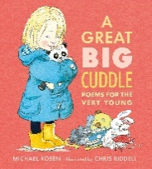  2016 CLiPPA  Joint winners  Sarah Crossan (One, Bloomsbury) & Michael Rosen (A Great Big Cuddle, illustrated by Chris Riddell, Walker) | 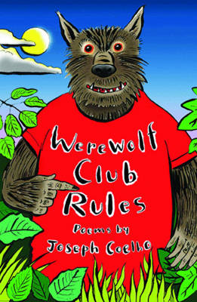  2015 CLiPPA  Joseph Coelho for Werewolf  Club Rules (Frances Lincoln)
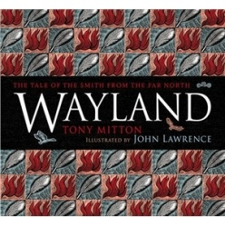  2014 CLPE Poetry Award  Tony Mitton for Wayland (David Fickling Books)  Joanne Limburg highly commended for Bookside Down (Salt Publishing) | 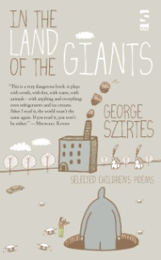  2013 CLPE Poetry Award  George Szirtes for In the Land of Giants, illustrated by Helen Szirtes (Salt Publishing)
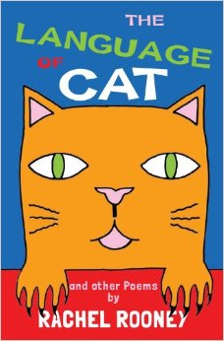  2012 CLPE Poetry Award  Rachel Rooney for The Language of Cat, illustrated by Ellie Jenkins (Frances Lincoln Publishing) | 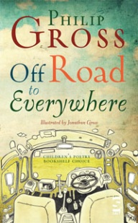  2011 CLPE Poetry Award  Philip Gross for Off Road to Everywhere, illustrated by Jonathan Gross (Salt Publishing)
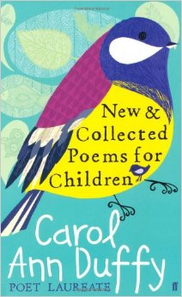  2010 CLPE Poetry Award  Carol Ann Duffy for New and Collected Poems for Children, illustrated by Alice Stevenson (Faber & Faber) | 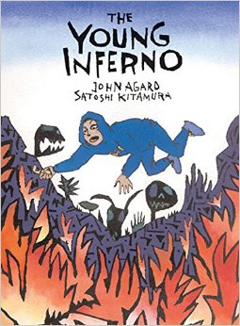  2009 CLPE Poetry Award  John Agard for The Young Inferno, illustrated by Satoshi Kitamura (Frances Lincoln)
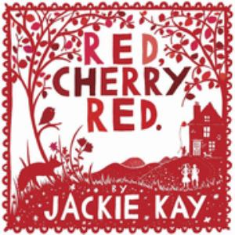  2008 CLPE Poetry Award  Jackie Kay for Red, Cherry Red, illustrated by Rob Ryan (Bloomsbury) | 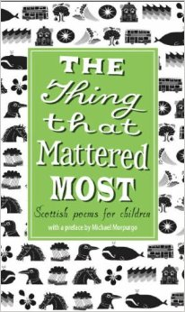  2007 CLPE Poetry Award  The Thing That Mattered Most, Scottish Poems for Children, edited by Julie Johnstone, illustrated by Iain McIntosh (Scottish PoetryLibrary/Black & White Publishing)
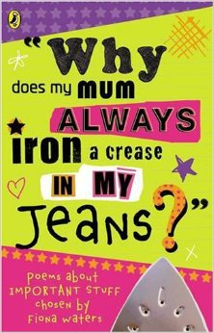  2006 CLPE Poetry Award  Why does my mum always iron a crease in my jeans?, edited by Fiona Waters (Puffin) | 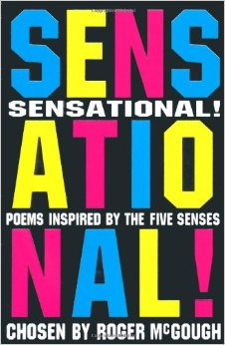  2005 CLPE Poetry Award  Sensational! Poems Inspired by the Five Senses, edited by Roger McGough (Macmillan)
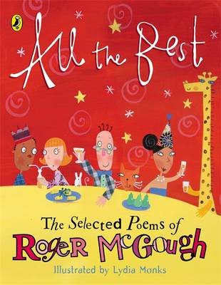  2004 CLPE Poetry Award  All the Best: The Selected Poems of Roger McGough (Puffin) | 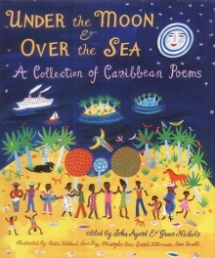  The first CLPE Poetry Award was awarded in 2003 to John Agard & Grace Nichols for their anthology Under the Moon and Over the Sea (Walker Books).

